### **AI-powered Nutrition Analyzer for Fitness Enthusiasts**

Team Leader **:** E.Santhiya

Team Member : P.Shalini, S.Sneha, M.Sridharan.

Faculty Mentor Name : Sweetline Sonia M

**Test The Model**

Evaluation is a process during the development of the model to check whether the model is the best fit for the given problem and corresponding data.

Load the saved model using load model

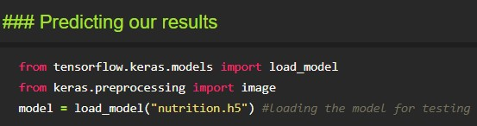

Taking an image as input and checking the results

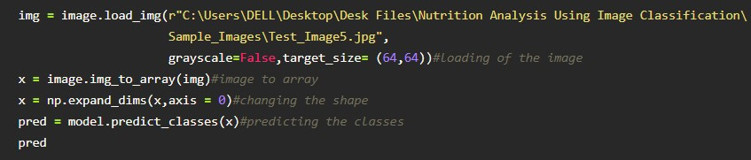

By using the model we are predicting the output for the given input image

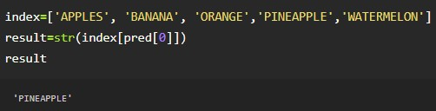

The predicted class index name will be printed here.